ENTITIES and THEIR ATTRIBUTES:

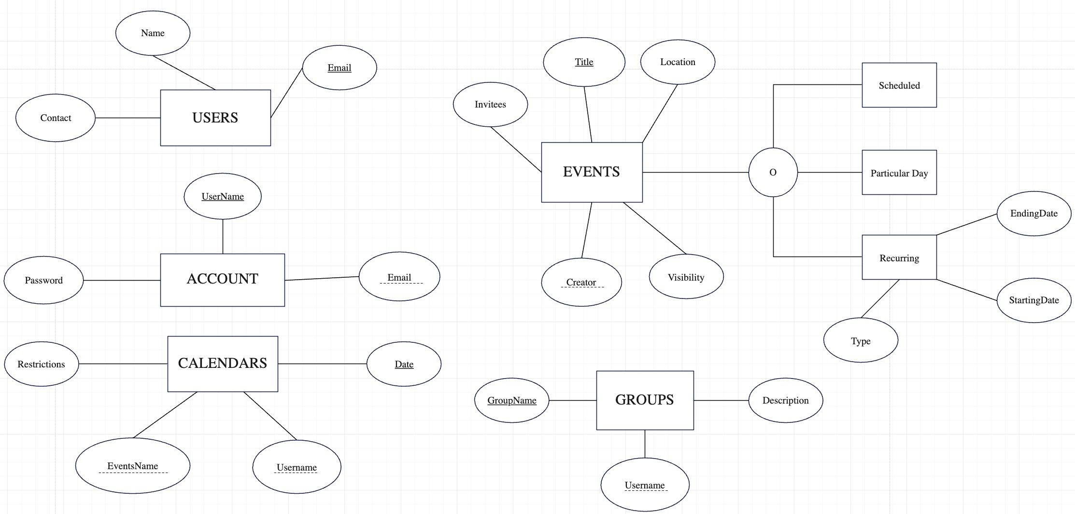

Notes/Assumptions:

* EventsName(in Calendars) references Title(in Events) which is the foreign key.
* Creator(in Events) references Username(in Account) which is the foreign key.
* Username(in Groups) references Username(in Account) which is the foreign key.
* The attribute ‘Visibility’(in Events) has two status, public and private respectively, a private event is shown simply as "Busy" in the interface.
* Events can be divided into three categories, it can be ‘Scheduled’, ‘Particular Day’ and ‘Recurring’, these entities can also have the attributes, such as location, Visibility......
* The attribute ‘Type’(in Recurring) has five values, they are on a particular day of the week, weekly, monthly, on the Xday of each month and annually.
* According to the difference of each date in calendar, this ER diagram sets ‘date’ as primary key.
* The attribute ‘Restrictions’(in Calendars) has three values, which every user can set it by themselves, it can be read/write, read-only and no access.

RELATIONSHIPS:

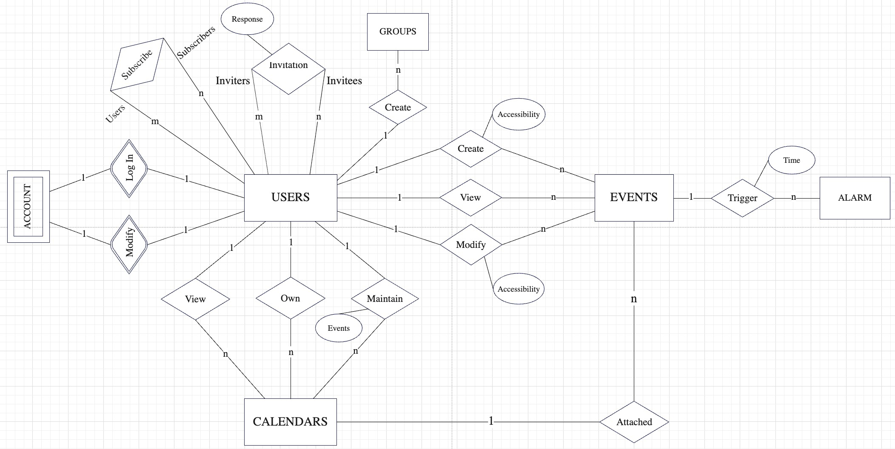

Notes/Assumptions:

* Due to the fact that no users means no account, the ACCOUNT is the weak entities of the USERS. And one user can just have one account.
* Only if other users set the calendars’ restrictions as Read/Write or Read-only, subscribers can subscribe their calendars.
* Users can invite other users to attend events, inviters can send invitations, invitees can accept inviters’ invitations by responding ‘yes’, they can refuse their invitations by responding ‘no’. The attribute of the relation ‘Invitation’ is response which reflects their reply.